22. Assessment of the Octopus Stock Complex in the Bering Sea and Aleutian Islands

Lee Cronin-Fine, Benjamin C. Williams, and Kerim Aydin

November 2023

This report may be cited as:  
Cronin-Fine. L, Williams. B. C. and Aydin. K, 2023. Assessment of the Octopus Stock in the Bering Sea and Aleutian Islands. North Pacific Fishery Management Council, Anchorage, AK. Available from <https://www.npfmc.org/library/safe-reports/>

# Executive Summary

Through 2010, octopuses were managed as part of the Bering Sea/Aleutian Islands (BSAI) “other species” complex, along with sharks, skates, and sculpins. Historically, catches of the other species complexes were well below TAC. Due to increasing market values, retention of species within the other species complex increased. Beginning in 2011, an amendment to the BSAI fisheries management plan provided separate management for sharks, skates, sculpins, and octopus and set catch limits for each species group. Initially, catch limits for octopus were set using Tier 6 methods based on the maximum historical incidental catch rate. Since 2012, a methodology based on consumption of octopus by Pacific cod (*Gadus macrocephalus*) has been used to set catch limits (see Conners *et al.* (2016) for methodological details).

This year’s assessment is an operational update, meaning new consumption data was provided through 2023 to determine catch limits using the previous assessment’s model/methodology. Alternative models/methodologies were not considered. At least eight species of octopus are found in the BSAI though in this update assessment, all octopus species are grouped into a single assemblage. The species composition of the octopus community is not well documented, but data indicate that the giant Pacific octopus (*Enteroctopus dofleini*) is the most common (Tables 22-1,-2,-3). Octopuses are taken as incidental catch in trawl, longline, and pot fisheries with a portion retained and sold for human consumption or bait. The BSAI trawl surveys produce highly variable biomass estimates for octopus (Figure 22-1).

## Summary of Changes in Assessment Inputs

*Changes in Input Data*

1. The calculation of annual and long-term average consumption rates has been updated using 13,614 additional Pacific cod stomach samples collected from 2012-2013 and 2016-2023.

*Changes in Assessment Methodology*

There have been no changes to the assessment methodology.

## Summary of Results

For 2024, the recommended maximum allowable ABC from the Tier 6 specifications is 4,560 t. Reference values for octopus are summarized in the following table, with the recommended ABC and OFL values for 2024 in bold.

|  | As estimated or *specified last* year for: | | As estimated or *recommended this* year for: | |
| --- | --- | --- | --- | --- |
| **Quantity/Status** | 2023 | 2024 | **2024** | 2025 |
| Tier | 6 | 6 | 6 | 6 |
| OFL (t) | 4,769 | 4,769 | **6,080** | 6,080 |
| *max*ABC (t) | 3,576 | 3,576 | 4,560 | 4,560 |
| ABC (t) | 3,576 | 3,576 | **4,560** | 4,560 |
|  | As determined *last* year for: | | As determined *this* year for: | |
| Status | 2021 | 2022 | 2022 | 2023 |
| Overfishing | No | n/a | No | n/a |

The BSAI octopus complex is not currently subject to overfishing.

## Responses to SSC and Plan Team Comments on Assessments in General

There were no Plan Team or SSC comments specific to this assessment

## Responses to SSC and Plan Team Comments Specific to this Assessment

There were no Plan Team or SSC comments specific to this assessment

# Introduction

The full introduction can be found in the 2020 BSAI octopus assessment (Ormseth *et al.* 2020). What follows is an abbreviation of the 2020 introduction.

Octopuses are marine mollusks in the class Cephalopoda. The cephalopods, whose name literally means head foot, have their appendages attached to the head and include octopuses, squids, and nautiluses. The octopuses (order Octopoda) have only eight appendages/arms and, unlike other cephalopods, lack shells, pens, and tentacles. There are two groups of Octopoda, the cirrate and the incirrate. The cirrate have cirri (cilia-like strands on the suckers), possess paddle-shaped fins suitable for swimming in their pelagic and epibenthic ocean habitats (Boyle and Rodhouse 2005), and are much less common than the incirrate, which contain the more traditional forms of octopus. Octopuses are found in every ocean in the world and range in size from less than 20 cm to over 3 m (total length); the latter is a record held by *Enteroctopus dofleini* (Wülker 1910). The most common octopus species observed in the AFSC bottom trawl survey is *E. dofleini*, but there are at least seven other species found in the Bering Sea: *Sasakiopus salebrosus*, *Benthoctopus leioderma*, *Benthoctopus oregonensis*, *Graneledone boreopacifica*, *Opisthoteuthis californiana*, *Japetella diaphana* and *Vampyroteuthis infernalis* . These eight species represent seven genera and can be found from less than 10-m to greater than 1500-m depth. All but one, *J. diaphana*, are benthic octopuses. The mesopelagic *V. infernalis* is a cephalopod that shares similarities with both octopuses and squids, but is included in the octopus assessment. The state of knowledge of octopuses in the BSAI, including the true species composition, is very limited.

# Fishery

A full description of the fishery’s history can be found in the 2020 BSAI octopus assessment (Ormseth *et al.* 2020). What follows are any recent significant changes to the fishery or management measures.

Directed Fishery

There is no federally-managed directed fishery for octopus in the BSAI. The State of Alaska allows for directed (under a special commissioner’s permit) and incidental catch of octopus in state waters. Since 2006, the number of permits for direct octopus fishing has been declining. The catch of octopus in state waters has been predominately incidental (Bevaart 2022; Nichols and Shaishnikoff 2022).

### *Incidental Catch*

Octopus are caught incidentally throughout the BSAI in both state and federally-managed bottom trawl, longline, and pot fisheries. Since 2003, the total octopus catch in federal waters (including discards) has been estimated using the National Marine Fisheries Service (NMFS) Alaska Regional Office catch accounting system. Total incidental catch range from approximately 200-700 t with high year-to year variability (Table 22-4). In 2011, the catch for octopus in BSAI (577 t) exceeded the OFL (528 t) resulting in NMFS closing the directed fishing for Pacific cod with pot gear in the BSAI on October 21, 2011. The following year, an alternative Tier 6 method for determining harvest levels was introduced. Since then, all catches have been nearly an order of magnitude below the recommended ABC (Table 22-4).

# Data

## Fishery

*Catch*

See Table 22-4 and Figure 22-2 for a time series of the total catch from 1997 to 2023. The 2023 catch data are incomplete. They were updated through September 16, 2023.

## Survey

### *AFSC Trawl Survey Biomass Estimates*

Bottom trawl surveys were conducted on an annual basis in the Eastern Bering Sea (EBS) shelf and biennially in the Aleutian Islands (AI) beginning in XXX. Both of these surveys were canceled in 2020 due to the COVID-19 pandemic. The EBS slope surveys were conducted irregularly and was last sampled in 2016. Estimated biomass for the octopus stock complex based on the AFSC bottom trawl surveys are shown in Tables 22-1,-2 and -3. Biomass estimates in the EBS and AI show high year-to-year variability (Figure 22-1). There is a large sampling variance associated with estimates from the shelf surveys because a large number of tows do not capture octopuses. It is impossible to determine how much of the year–to-year variability in the estimated biomass reflects true variation in abundance or is a result of sampling variation. For example, the 1997 biomass estimate from the shelf survey (254 t) approximately equaled the estimated commercial catch (249 t). This suggests that the 1997 biomass estimate was unreasonably low. The 2023 EBS biomass estimate (2,557 t) is a decrease of 48% from 2022 (4,941 t). The 2023 EBS biomass estimate is also 39% lower than the long-term average biomass estimate (4,189 t) and is the lowest biomass estimate since 2014.

## Other Data

The BSAI octopus assessment utilizes diet data from Pacific cod, the main predator of octopus in the BSAI. These data are available from the AFSC food habits group (Table 22-5). A total of 13,614 stomachs from 2012-2013 and 2016-2023 have been added to the data set since the last assessment update in 2016.

# Analytical approach

## General Model Structure

The available data for octopus in the BSAI do not support quantitative catch-at-age modeling for either individual species of octopus or for the multi-species complex. There are also no reliable biomass estimates available for Tier 5 methods. Therefore, we continue to use the alternative Tier 6 method, based on a predation-based estimate of total natural mortality (*N*) (Conners *et al.* 2011). We use the letter *N* for the total natural mortality in tons to distinguish it from the *M* (continuous individual mortality rate) that is used widely in other stock assessment models (Ormseth et al. 2020).

This alternative Tier 6 method utilizes diet data from the AFSC’s food habits database to estimate the total amount of octopus consumed by their main predator in the BSAI: Pacific cod. The estimated amount of octopus consumed by Pacific cod is thought to be a conservative estimate of the total natural mortality *N* for octopus, since it does not include mortality from other predators (i.e., marine mammals) or non-predation mortality. It is important to note that this methodology calculates a single reference point that is averaged over multiple years in order to avoid assuming a population increase when it is just an increase in predation. Therefore, the reference point should be periodically updated but not annually. This analysis was first performed in 2011 (Conners *et al.* 2011) and last updated in the 2016 assessment (Conners *et al.* 2016).

## Parameter Estimates

*Total Natural Mortality (N)*  
*N* was estimated using previously defined methods. See “General Model Structure” for a description and the 2016 BSAI octopus assessment (Conners *et al.* 2016) for more details.

# Results

## Harvest Recommendations

*Amendment 56 Reference Points*   
In previous assessments, catch limits for the octopus stock complex were set using Tier 6 methods based on the maximum historical incidental catch rate Beginning in 2012, an alternative tier 6 method based on predation-based estimate of total natural mortality (N) was adopted that is based on biological reference points derived from octopus consumption estimates from Pacific cod. This estimate of natural mortality (*N*) can then be combined with the general logistic fisheries model that forms the basis of Tier 5 assessments (Alverson and Pereyra 1969; Francis 1974). Thus, the overfishing limit is set equal to *N*, and the recommended maximum permissible ABC for the octopus stock complex is defined to occur at a harvest rate of 0.75\**OFL.*

*Specification of OFL and Maximum Permissible ABC*

**Using the modified tier 6 methodology, the resulting catch limits are OFL = 6,080 t and ABC = 4,560 t which are our recommended 2024 and 2025 ABCs and OFLs.**

We do not recommend a directed fishery for octopus in federal waters at this time, because data are insufficient for adequate management. We anticipate that octopus catch in federal waters of the BSAI will continue to be largely incidental catch in existing groundfish fisheries.

*Status Determination*  
The BSAI octopus complex is not currently subject to overfishing.

# Ecosystem Considerations

A full description of the ecosystem considerations can be found in the 2020 BSAI octopus assessment (Ormseth *et al.* 2020). What follows is an abbreviation from the 2020 BSAI octopus assessment.

Little is known about the role of octopus in North Pacific ecosystems. Food habits data and ecosystem modeling of the Bering Sea and AI (Livingston *et al.* 2003; Aydin *et al.* 2008) indicate that octopus diets are dominated by other benthic invertebrates such as mollusks, hermit crabs, starfish, and snow crabs. Octopus mortality comes primarily from Pacific cod, resident seals, walrus, bearded seals, and sculpins. The majority of the octopus incidental catch is taken in pot gear fished for Pacific cod. To avoid gear conflicts with trawlers, cod pots are usually deployed inside of no-trawl zones or in rocky areas unsuitable for trawling. The low retention rate of octopus in the BSAI, and the high survival rate of discarded octopus suggest that effects on the octopus population is minor.

# Data Gaps and Research Priorities

A full description of the data gaps and research priorities can be found in the 2020 BSAI octopus assessment (Ormseth *et al.* 2020). What follows is an abbreviation from the 2020 BSAI octopus assessment.

Though there have been efforts to improve the collection of basic octopus data, there is still a lot that is unknown. The areas of needed/ongoing research include improving aging methods, determining octopus species composition in catch and survey, determining octopus distribution especially when reproducing and producing reliable fisheries independent biomass estimates.

# References

Alverson, D.L. and Pereyra, W.T. (1969) Demersal fish explorations in the northeastern Pacific ocean – an evaluation of exploratory fishing methods and analytical approaches to stock size and yield forecasts. *Journal of the Fisheries Research Board of Canada* 26, 1985–2001.

Aydin, K., Gaichas, S., Ortiz, I., Kinzey, D. and Friday, N. (2008) A comparison of the Bering Sea, Gulf of Alaska, and Aleutian Islands large marine ecosystems through food web modeling. NOAA Tech Memo.

Bevaart, K. (2022) Annual management report for shellfish fisheries in the Kodiak, Chignik, and South Peninsula Districts, 2021. Alaska Department of Fish; Game, Fishery Management Report No. 22-18, Anchorage.

Boyle, P. and Rodhouse, P. (2005) *Cephalopods: Ecology and Fisheries*. Blackwell Publishing, Oxford, UK.

Conners, M.E., Aydin, K.Y. and Conrath, C.L. (2016) Assessment of the octopus stock complex in the Bering Sea and Aleutian Islands. In: *Stock assessment and fishery evaluation report for the groundfish resources of the Bering Sea and Aleutian Islands regions*. North Pacific Fishery Management Council, Anchorage, AK.

Conners, M.E., Conrath, C.L. and Aydin, K. (2011) Assessment of the octopus stock complex in the Bering Sea and Aleutian Islands. In: *Stock assessment and fishery evaluation report for the groundfish resources of the Bering Sea and Aleutian Islands regions*. North Pacific Fishery Management Council, Anchorage, AK.

Francis, R.C. (1974) Relationship of fishing mortality to natural mortality at the level of maximum sustainable yield under the logistic stock production model. *Journal of the Fisheries Research Board of Canada* 31, 1539–1542.

Livingston, P.L., Aydin, K.Y., Boldt, J., Gaichas, S., Ianelli, J., Jurado-Molina, J. and Ortiz, I. (2003) Ecosystem assessment of the Bering Sea/Aleutian Islands and Gulf of Alaska management regions. In: *Stock assessment and fishery evaluation report for the groundfish resources or the Bering Sea/Aleutian Islands regions*. North Pacific Fishery Management Council, Anchorage, AK.

Nichols, E. and Shaishnikoff, J. (2022) Annual management report for shellfish fisheries of the Bering Sea/Aleutian Islands Management Area, 2021/22. Alaska Department of Fish; Game, Fishery Management Report No. 22-28, Anchorage.

Olav A. Ormseth, Elizabeth M. Conners, Aydin, K. and Conrath, C.L. (2020) Assessment of the octopus stock complex in the Bering sea and Aleutian islands. In: *Stock assessment and fishery evaluation report for the groundfish resources of the Bering Sea and Aleutian Islands regions*. North Pacific Fishery Management Council, Anchorage, AK.

Wülker, G. (1910) Uber Japanische cephalopoden: Beitrage zur kenntnis der systematik und anatomie der dibranchiaten. *Abhandlungen der Mathematisch-Physikalischen Classe der Koniglich Bayerischen Akademie der Wissenschaften* 1, 1–77.

# Tables

Table 22-1. AFSC Aleutian Islands trawl survey biomass estimates (t) for octopus species. CV is coefficient of variation. “Other Octopus” include *B. leioderma, J. diaphana, S. salebrosus, B. oregonensis* and octopus unidentified.

|  | *E. dofleini* | | Other Octopus | | Total | |
| --- | --- | --- | --- | --- | --- | --- |
| **Year** | **Biomass** | **CV** | **Biomass** | **CV** | **Biomass** | **CV** |
| 1991 | 57 | 45 | 1,102 | 21 | 1,159 | 20 |
| 1994 | 1,186 | 27 | 541 | 21 | 1,727 | 19 |
| 1997 | 451 | 50 | 769 | 27 | 1,219 | 25 |
| 2000 | 444 | 45 | 345 | 38 | 788 | 30 |
| 2002 | 623 | 25 | 769 | 47 | 1,393 | 28 |
| 2004 | 4,076 | 35 | 20 | 98 | 4,095 | 34 |
| 2006 | 3,037 | 17 | 25 | 69 | 3,062 | 17 |
| 2010 | 3,074 | 30 | 1 | 55 | 3,075 | 30 |
| 2012 | 2,739 | 42 | 41 | 52 | 2,779 | 42 |
| 2014 | 2,762 | 20 | 83 | 21 | 2,845 | 20 |
| 2016 | 3,752 | 24 | 81 | 93 | 3,833 | 24 |
| 2018 | 2,231 | 40 | 44 | 87 | 2,274 | 39 |
| 2022 | 1,505 | 23 | 0 | 72 | 1,505 | 23 |

Table 22-2. AFSC EBS shelf trawl survey biomass estimates (t) for octopus species. CV is coefficient of variation. “Other Octopus” include *B. leioderma, S. salebrosus, B. oregonensis* and octopus unidentified.

|  | *E. dofleini* | | Other Octopus | | Total | |
| --- | --- | --- | --- | --- | --- | --- |
| **Year** | **Biomass** | **CV** | **Biomass** | **CV** | **Biomass** | **CV** |
| 1987 | 4,181 | 88 | 3,648 | 47 | 7,829 | 52 |
| 1988 | 5,921 | 42 | 3,944 | 37 | 9,865 | 29 |
| 1989 |  |  | 4,895 | 33 | 4,895 | 33 |
| 1990 |  |  | 11,589 | 48 | 11,589 | 48 |
| 1991 |  |  | 8,070 | 34 | 8,070 | 34 |
| 1992 |  |  | 5,607 | 42 | 5,607 | 42 |
| 1993 |  |  | 1,582 | 34 | 1,582 | 34 |
| 1994 |  |  | 2,480 | 39 | 2,480 | 39 |
| 1995 |  |  | 2,934 | 59 | 2,934 | 59 |
| 1996 |  |  | 1,809 | 68 | 1,809 | 68 |
| 1997 |  |  | 254 | 40 | 254 | 40 |
| 1998 | 548 | 100 | 738 | 49 | 1,285 | 51 |
| 1999 |  |  | 834 | 52 | 834 | 52 |
| 2000 | 465 | 100 | 1,563 | 44 | 2,028 | 41 |
| 2001 | 100 | 69 | 5,785 | 32 | 5,885 | 32 |
| 2002 | 641 | 95 | 1,860 | 49 | 2,502 | 44 |
| 2003 | 5,163 | 65 | 3,091 | 58 | 8,254 | 46 |
| 2004 | 4,919 | 31 | 35 | 86 | 4,954 | 31 |
| 2005 | 9,558 | 30 | 657 | 48 | 10,215 | 28 |
| 2006 | 1,570 | 40 | 334 | 44 | 1,904 | 34 |
| 2007 | 2,113 | 31 | 163 | 45 | 2,276 | 29 |
| 2008 | 1,013 | 48 | 157 | 62 | 1,170 | 42 |
| 2009 | 819 | 64 | 195 | 53 | 1,013 | 53 |
| 2010 | 642 | 59 | 169 | 50 | 811 | 48 |
| 2011 | 2,833 | 33 | 708 | 66 | 3,541 | 30 |
| 2012 | 2,088 | 39 | 478 | 37 | 2,566 | 32 |
| 2013 | 1,657 | 53 | 156 | 41 | 1,813 | 49 |
| 2014 | 2,078 | 54 | 256 | 52 | 2,334 | 49 |
| 2015 | 5,223 | 31 | 115 | 62 | 5,338 | 30 |
| 2016 | 6,927 | 47 | 515 | 28 | 7,442 | 44 |
| 2017 | 1,777 | 44 | 2,240 | 27 | 4,017 | 24 |
| 2018 | 4,648 | 29 | 603 | 37 | 5,251 | 26 |
| 2019 | 5,538 | 26 | 378 | 38 | 5,916 | 24 |
| 2021 | 5,026 | 31 | 28 | 67 | 5,054 | 31 |
| 2022 | 4,628 | 28 | 313 | 71 | 4,941 | 26 |
| 2023 | 2,518 | 32 | 39 | 38 | 2,557 | 32 |

Table 22-3. AFSC eastern Bering Sea slope trawl survey biomass estimates (t) for octopus species. CV is coefficient of variation. “Other Octopus” include *B. leioderma, G. boreopacifica, J. diaphana, S. salebrosus, B. oregonensis, O. californiana* and octopus unidentified.

|  | *E. dofleini* | | Other Octopus | | Total | |
| --- | --- | --- | --- | --- | --- | --- |
| **Year** | **Biomass** | **CV** | **Biomass** | **CV** | **Biomass** | **CV** |
| 2002 | 410 | 39 | 560 | 12 | 971 | 18 |
| 2004 | 993 | 24 | 987 | 15 | 1,980 | 14 |
| 2008 | 336 | 33 | 445 | 15 | 781 | 17 |
| 2010 | 216 | 33 | 405 | 15 | 621 | 15 |
| 2012 | 647 | 43 | 771 | 15 | 1,419 | 21 |
| 2016 | 566 | 31 | 1,697 | 14 | 2,263 | 13 |

Table 22-4. Estimated catch (t) of all octopus species from 1997-2023 in the Bering Sea and Aleutian Islands, by target fishery. Data reflect catch posted through September 16, 2023 (sourced September 29, 2023 from the NMFS Alaska Regional Office using the AKFIN database (http://www.akfin.org)). Catch is divided into three groups based on the target fishery; Pacific cod (typically highest octopus catch), all species of flatfish and all other target fisheries combined. Pacific halibut are included in the 'other' category. Octopus did not have their own catch limits until 2011. An alternative Tier 6 method was adopted in 2012.

|  | **Target Fishery** | | | | |  | | | |  |
| --- | --- | --- | --- | --- | --- | --- | --- | --- | --- | --- |
| **Year** | **P.cod** | **Flatfish** | **Other** | **Total** | **Retained** | **OFL** | **ABC** | **TAC** | **Catch/ABC** | **Management Measures** |
| 1997 | 160 | 86 | 3 | 249 |  |  |  |  |  |  |
| 1998 | 168 | 13 | 9 | 190 |  |  |  |  |  |  |
| 1999 | 310 | 14 | 2 | 326 |  |  |  |  |  |  |
| 2000 | 359 | 57 | 3 | 419 |  |  |  |  |  |  |
| 2001 | 211 | 9 | 7 | 227 |  |  |  |  |  |  |
| 2002 | 334 | 21 | 19 | 374 |  |  |  |  |  |  |
| 2003 | 224 | 32 | 21 | 277 | 31% |  |  |  |  |  |
| 2004 | 278 | 44 | 246 | 569 | 55% |  |  |  |  |  |
| 2005 | 311 | 17 | 10 | 339 | 64% |  |  |  |  |  |
| 2006 | 331 | 5 | 14 | 350 | 55% |  |  |  |  |  |
| 2007 | 156 | 7 | 9 | 171 | 41% |  |  |  |  |  |
| 2008 | 196 | 11 | 8 | 215 | 36% |  |  |  |  |  |
| 2009 | 58 | 10 | 6 | 73 | 22% |  |  |  |  |  |
| 2010 | 168 | 12 | 5 | 185 | 29% |  |  |  |  |  |
| 2011 | 555 | 9 | 14 | 577 | 6% | 528 | 396 | 150 | 146% |  |
| 2012 | 126 | 4 | 8 | 137 | 17% | 4,769 | 3,576 | 900 | 4% |  |
| 2013 | 214 | 2 | 4 | 220 | 22% | 4,769 | 3,576 | 500 | 6% |  |
| 2014 | 406 | 5 | 18 | 429 | 20% | 4,769 | 3,576 | 225 | 12% |  |
| 2015 | 412 | 6 | 24 | 441 | 18% | 4,769 | 3,576 | 400 | 12% |  |
| 2016 | 554 | 5 | 34 | 593 | 16% | 4,769 | 3,576 | 400 | 17% |  |
| 2017 | 264 | 4 | 13 | 282 | 31% | 4,769 | 3,576 | 400 | 8% |  |
| 2018 | 262 | 4 | 23 | 290 | 59% | 4,769 | 3,576 | 250 | 8% |  |
| 2019 | 238 | 13 | 17 | 268 | 48% | 4,769 | 3,576 | 400 | 7% |  |
| 2020 | 672 | 3 | 16 | 691 | 21% | 4,769 | 3,576 | 275 | 19% |  |
| 2021 | 154 | 8 | 8 | 170 | 13% | 4,769 | 3,576 | 700 | 5% |  |
| 2022 | 222 | 8 | 21 | 251 | 29% | 4,769 | 3,576 | 700 | 7% |  |
| 2023* | 81 | 5 | 35 | 120 | 49% | 4,769 | 3,576 | 400 | 3% |  |
| *2023 catch as of September 16, 2023, sourced September 29, 2023 from the NMFS Alaska Regional Office using the AKFIN database (http://www.akfin.org). | | | | | | | | | |  |

Table 22-5. Number of Pacific cod stomach samples, from 1984-2023, analyzed for octopus consumption estimates. A total of 52,843 stomachs were analyzed.

| **Year** | **# of Samples** | **Year** | **# of Samples** |
| --- | --- | --- | --- |
| 1984 | 581 | 2004 | 0 |
| 1985 | 793 | 2005 | 449 |
| 1986 | 1,351 | 2006 | 705 |
| 1987 | 790 | 2007 | 583 |
| 1988 | 573 | 2008 | 1,208 |
| 1989 | 1,678 | 2009 | 1,345 |
| 1990 | 1,157 | 2010 | 1,198 |
| 1991 | 1,597 | 2011 | 1,550 |
| 1992 | 1,903 | 2012 | 1,838 |
| 1993 | 2,317 | 2013 | 1,657 |
| 1994 | 2,397 | 2014 | 1,644 |
| 1995 | 2,420 | 2015 | 1,942 |
| 1996 | 1,336 | 2016 | 1,954 |
| 1997 | 1,165 | 2017 | 1,611 |
| 1998 | 1,272 | 2018 | 1,619 |
| 1999 | 1,313 | 2019 | 1,246 |
| 2000 | 1,405 | 2020 | 0 |
| 2001 | 1,428 | 2021 | 1,565 |
| 2002 | 1,333 | 2022 | 985 |
| 2003 | 1,796 | 2023 | 1,139 |

# Figures

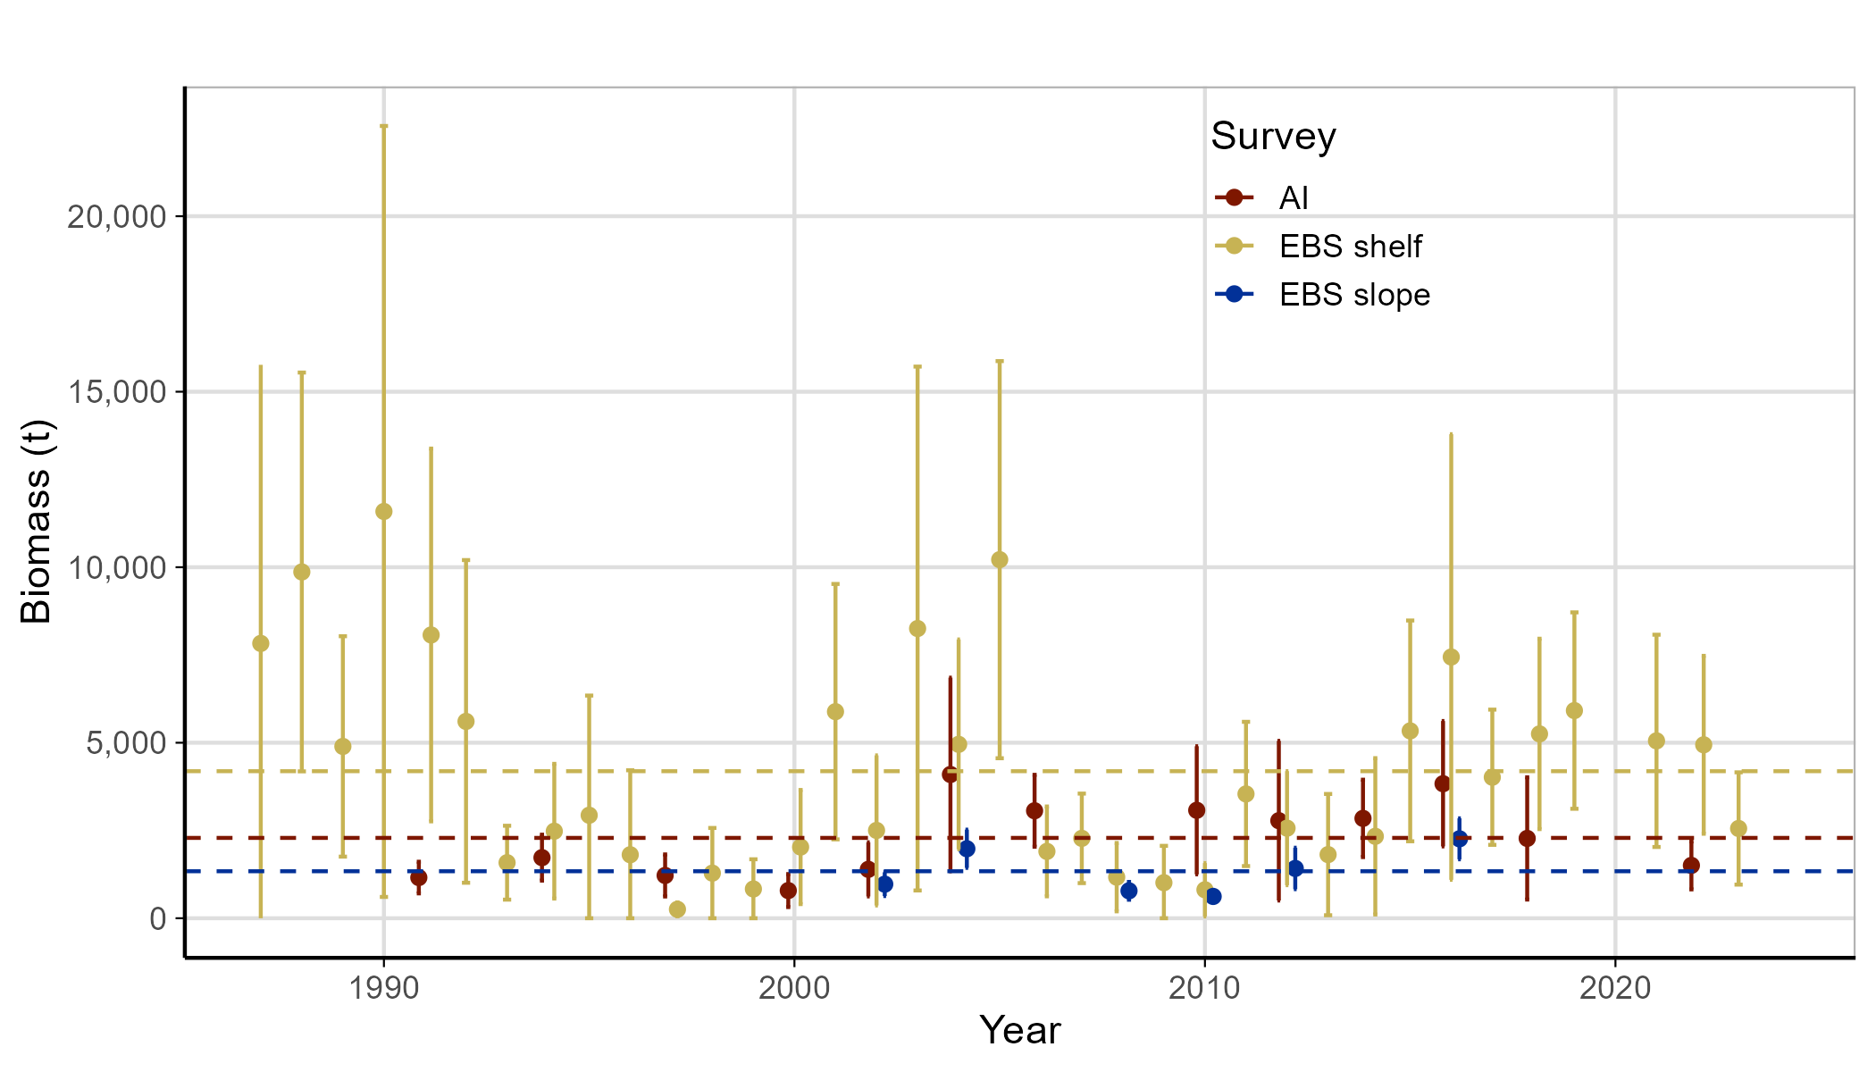

Figure 22-1. Octopus biomass estimates from the Eastern Bering Sea (EBS) shelf (1987-2023), EBS slope (2002-2016) and Aleutian Islands (AI) (1991-2022) surveys. The horizontal dashed lines represent the long-term average biomass for the survey with the same color. The long-term average for the AI is 2,289 t, the EBS shelf is 4,189 t and the EBS slope is 1,339 t.

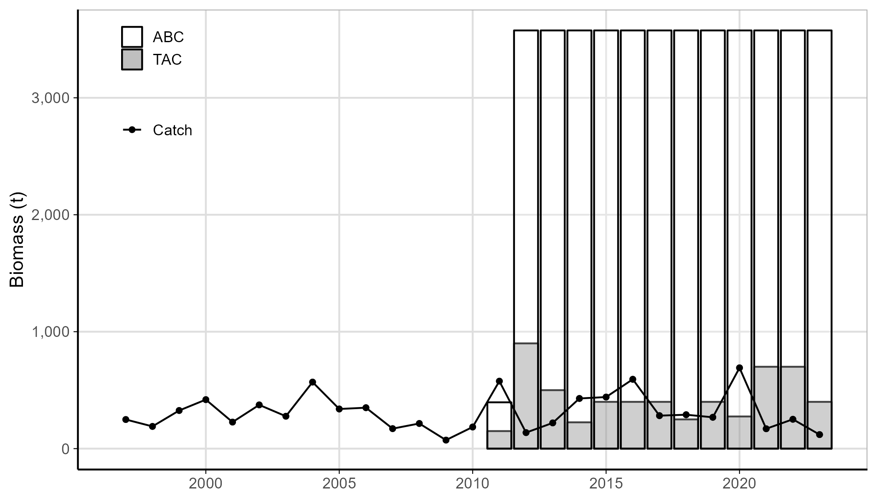

Figure 22-2. Octopus catch (retained and discarded), ABC and TAC from 1997-2023. Data reflect catch posted through September 16, 2023 (sourced September 29, 2023 from the NMFS Alaska Regional Office using the AKFIN database (<http://www.akfin.org>)).